Rate Limiter as a Service
Owner: Alok Manawat
Duration: 10/09/2026 – 04/10/2026
Tech Stack: Spring Boot, Maven

Abstract
This is the documentation of a Rate Limiter API, implemented in Java with Spring Boot. The core idea of a rate limiter is to gate-keep the number of requests per endpoint made by users. Since a server can only handle a limited number of requests, some requests must be denied or delayed. Backend services can register on the platform, get an API key, and then check each incoming request against the /api/check endpoint before handling it, which responds with allow or deny.

Introduction
What is a rate limiter? A rate limiter, in software products, is anything that controls how much traffic reaches a server, so it doesn't get overwhelmed by too many requests at once.

Why do we need it?
- When millions of requests hit a server, it takes time to respond, which can cause user dissatisfaction. That's why we need to control the traffic so the server can respond in time.
- It also protects a server from a DoS (Denial of Service) attack, where a person or bot sends so many requests that the server gets overwhelmed and stops serving genuine users.

Implementation and Working
I implemented this rate limiter service in Spring Boot, with two variants — one uses in-memory storage and the other uses Redis. I implemented three algorithms for rate limiting: Token Bucket, Sliding Window Log, and Sliding Window Counter.

Token Bucket
Limits the number of tokens — each request takes 1 token, and requests are denied once the tokens are drained out. The refill logic is what keeps things going: the bucket is given a capacity and a time period, over which it keeps refilling with tokens. So on one side, requests take a token (if available), and on the other, the bucket keeps refilling at a fixed rate (capacity / time).

Sliding Window Log
A queue maintains timestamps of requests, up to a maximum size — once the queue is full, it denies the request. The popping of old entries acts as the refill here: timestamps older than the window (in seconds) are popped off before each check.

Sliding Window Counter
Keeps track of the number of requests in the current window and the number in the previous window, and calculates a weighted sum of the two. The window slides every second, which gradually makes room for new requests.

Challenges
- One of the big problems was scaling the rate limiter. Scaling it horizontally means running multiple instances of the server, and in-memory storage then ends up duplicating each client's allowance across instances instead of sharing it.
Solution: Use a shared cache, such as Redis, which stays consistent across all instances.
- Race conditions: when multiple instances run at the same time, they can read and modify the shared state at the same time, causing a race condition — both instances might read the same value, both decide independently to allow the request, and one write ends up overwriting the other.
Solution: Use Lua scripting for atomic operations. Redis runs the script on its own server as a single unit, so the operation stays synchronized.

Architecture
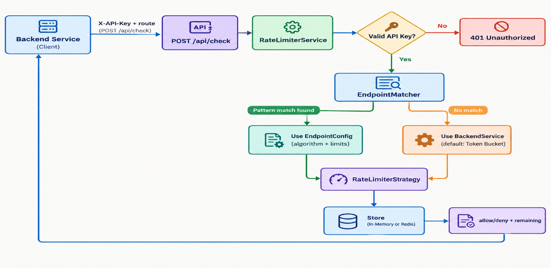

Comparing the Two Variants (In-Memory vs. Redis-Backed) Across 2 Instances
The same scenario was run against two instances of the service (ports 8080 and 8081), with requests alternating between them to simulate traffic coming through a load balancer.
=== IN-MEMORY MODE: alternating between :8080 and :8081 ===
Request 1 -> port 8081 -> status 200, remaining 4
Request 2 -> port 8080 -> status 200, remaining 4
Request 3 -> port 8081 -> status 200, remaining 3
Request 4 -> port 8080 -> status 200, remaining 3
Request 5 -> port 8081 -> status 200, remaining 2
Request 6 -> port 8080 -> status 200, remaining 2
Request 7 -> port 8081 -> status 200, remaining 1
Request 8 -> port 8080 -> status 200, remaining 1
Request 9 -> port 8081 -> status 200, remaining 0
Request 10 -> port 8080 -> status 200, remaining 0

=== REDIS MODE: alternating between :8080 and :8081 ===
Request 1 -> port 8081 -> status 200, remaining 4
Request 2 -> port 8080 -> status 200, remaining 3
Request 3 -> port 8081 -> status 200, remaining 2
Request 4 -> port 8080 -> status 200, remaining 1
Request 5 -> port 8081 -> status 200, remaining 0
Request 6 -> port 8080 -> status 429, remaining 0
Request 7 -> port 8081 -> status 429, remaining 0
Request 8 -> port 8080 -> status 429, remaining 0
Request 9 -> port 8081 -> status 429, remaining 0
Request 10 -> port 8080 -> status 429, remaining 0

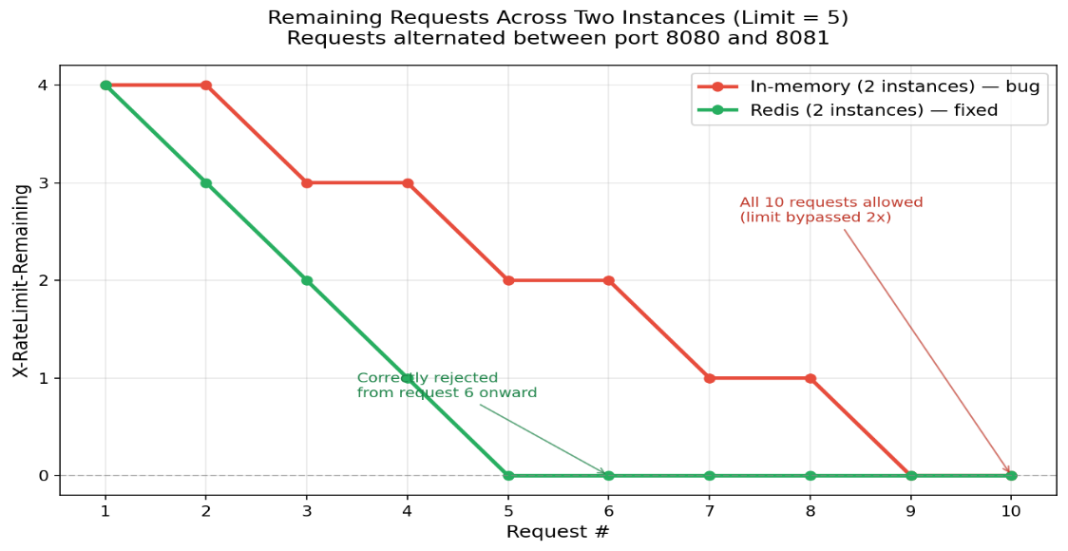

Conclusion
For distributed systems, Redis-backed rate limiting is the accurate choice, since the state is shared across all the servers.
The Redis-backed system does have one flaw, though: Redis guarantees a Lua script runs atomically — no other client's commands can interleave with it while it runs — but it does not guarantee a transactional rollback. If one command inside the script fails partway through, whatever already ran before that point stays in place; it isn't undone. So the script has to be written carefully, with that in mind.

Future Plans
Currently working on load balancers and a reverse-proxy API gateway, which will extend the system design skills applied here.

